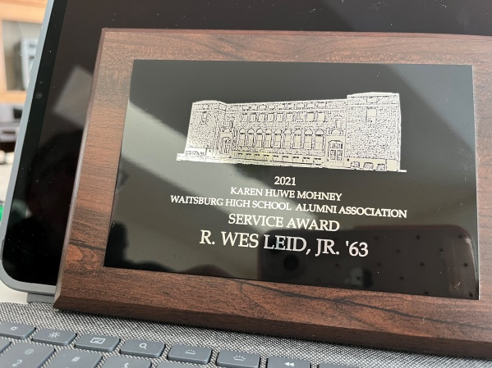
WES LEID was awarded the 2021 Karen Huwe Mohney Waitsburg High School Alumni Association Service Award just days before he passed. The following words are written by Katie Mantz Leid--How does one talk about a six year old attending first grade for the first time, scared to death, knowing that many of his peers had attended Kindergarten the year before? His parents could not afford to send him to Kindergarten. Mrs. Combs was an amazing nurturer for him, and he moved on to second grade with Mrs. Keve. Well, that was a wake up call, and he rose to the occasion.

Roy’s job took the family to Pullman for the remainder of his second grade year, and part of his third grade year where he expanded his horizons and friendships. The family moved back to Waitsburg during the spring of his third grade year—so, technically, he attended Waitsburg schools all twelve years!

Wes was on safety patrol in elementary school, achieve the “4th Award” as an eighth grader, and moved on to high school. During his high school career, he made sure that no one got in his way to succeed. He was a 4-year letterman; went to the state track meet with a classmate (Mike Vennum), and lo and behold, they roomed together at Whitworth for their first year with Wes playing Football, and Mike running track.

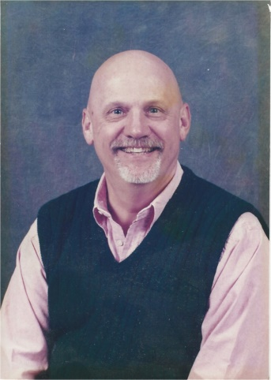
After 1-½ years at Whitworth, Wes transferred to Central Washington College (University) to play football for Mel Thompson. It was that spring that his coach took a coaching position at University of Washington. That led to huge decisions for his family as well as the Mantz family, because it meant that these two would move out of state to pursue Wes’s dreams. Wes married Katie in August 1966 and after graduating from CWC in 1970, the family, with a new baby, moved to East Lansing, Michigan.

Fast forward to a PhD at Michigan State University, a post Doctorate at Harvard, leading to an Instructor in Medicine, then back to MSU to teach and conduct research in Veterinary Medicine. Shortly after returning to MSU, Washington State University thought he would be a great fit. In 1980, Wes and his family moved to WSU.

From that time on, Wes would drive to Waitsburg to help in any way with the Pioneer Fall Festivals, talk to various classes on the Holocaust, always explaining what it means for a Waitsburg son to achieve his dreams, and touch hundreds of students. He became President of the WHS Alumni Association while a professor in Pullman, and had a vision of how the association could move from a “committee for the banquet” to a functioning board. He brought up that idea to the current committee, and an Alumni Board was created.

Jeff Broom, a life long friend, and he were brainstorming, and they came up with the idea of creating a WHS Alumni Scholarship similar to what Dayton High School had. Katie was the elementary Principal in Dayton and knew first hand how much their scholarships meant to DHS students. Fast forward again:

Today, 2022, the WHS Alumni Scholarship is self-sustaining, and this year $7,000 will be distributed to five alumni and/or seniors. Wes didn’t do this alone. The Broom family, Leid family, Baker family, Danforth family, and many others thought this idea was worth while and because of the vision of the above mentioned, today, the fund stands at $155,000, with the potential to grow exponentially.

The Alumina Board also started a newsletter sharing information about the Association and featuring Alumina who have chosen interesting and fulfilling careers after graduating from WHS. Wes would contact these Alumina, interview them, get a picture or two, and write the articles for the newsletters.

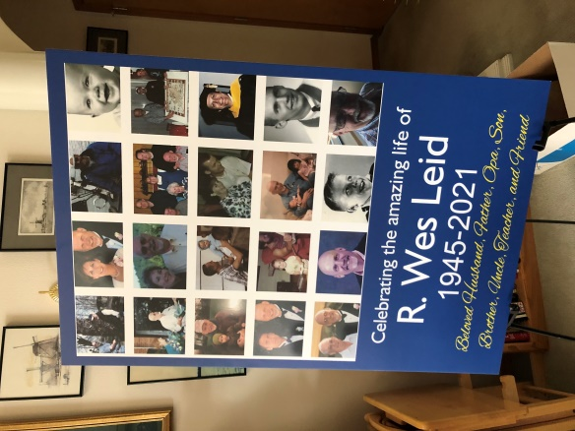
In light of how the fund was started, and Wes’s contribution to the WHS Alumni Association over his 55 plus years, (such as taking over Roy’s duty of “Calling the Classes,” along with his brother, Jim, with a no nonsense “get yourselves in line” tone; greeting and visiting with every single person at the banquet, making sure that the purpose of the Association was to connect with friends of all ages, and to promote young people who could see that “the sky was the limit.”

So often, when Wes was talking with groups, friends, acquaintances, he told the story of growing up with very little money, to becoming a successful professor, giving back, just like his parents did. He would tell all of you reading or listening to this: “Give of your time, and or your money, dig deep, for the benefit of other WHS graduates whose confidence in first grade could grow into something bigger and better to help others achieve their goals in life

